Git Workflow

To resolve the issue
1. To resolve the warnings making changes in the master branch is not a good practice. We need to create a new branch and then make changes in the code.
Creating new branch

2. Go inside ara-api folder
i. cd ara-project/ara-api

3. Check for the current branch you are working in
ii. git branch
To display currently you are in which branch

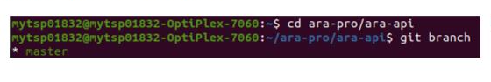

Note:-

As mentioned above, if the branch is “ *master ”, don’t commit any changes as it is the source branch, so we have to checkout a new branch and try to commit your new changes there and submit for the review.

4. The git checkout commands let you create and switch to a new branch. The git checkout -b option is a convenience flag that performs run git branch <new-branch>operation before running git checkout <new-branch>.

iii. git checkout -b <branch name>
Note:
• -b specifies creating new branch. If the branch is already created just use
• git checkout <branch name> → to switch to your particular branch which is already created.
• Naming of the branch should follow the AUTOSAR guidelines.
• Please prefix <topic>/<ticket-number>-<jira-issue> for merge requests containing only one new commit.
Ex: git checkout -b bugfix/AR97670-Logging-RapidJson-errors

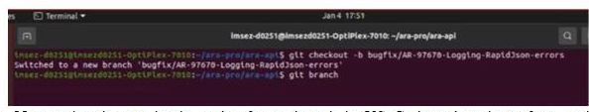

5. Now make changes in the code of new branch in VS Code and again perform native compilation to check whether the warning/s or error are resolved. If yes then proceed with next step else try other approaches to resolve the issue.
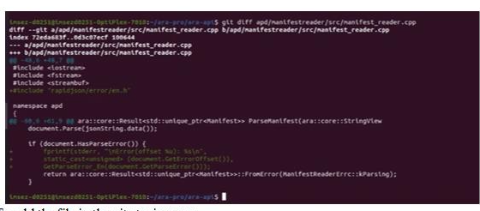

6. To check for all the files which are modified in ara-api, give the below command as shown in the figure.

iv. git status

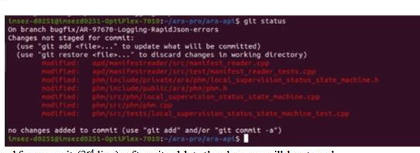

Here we can observe that changes are not staged for commit (3rd line), after git add -> the changes will be staged.

7. If you want to check the changes that have been done in a particular file.

v. git diff <path - to - the - specified – file>
Ex:
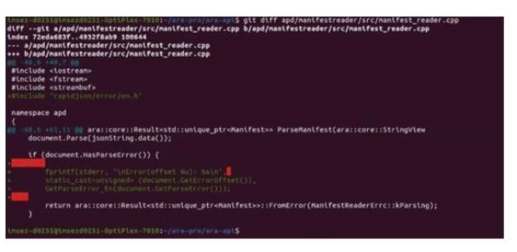

It will also display the extra space (red color) which are present in the code you written, refer that and remove the unnecessary spaces in your code. Again give git
diff command and check whether it is removed.

8. To add the file in the git staging area

vi. git add <path - to - the - specified – file>
Note:
• The file will be added to the git staging area irrespective of the branch you are currently in and here we are adding only the path of the files in which changes have been made because sending other files or whole code is unnecessary as it consumes more memory.
• Give git status command to check whether it is added to git staging area.
• We can observe that only the particular file which we have given to git add has been added to staging area (4th line) to commit for changes and remaining files have not staged for commit.
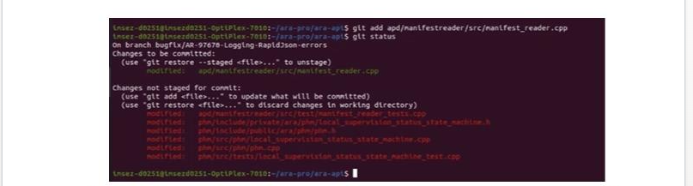

9. Commit the changes into the GitLab platform, that will create a new branch in the CI/CD platform, using that we can create a merge request and also if we want to commit any new changes from this, we can push it to this branch. And whenever the branch gets reviewed and merged into the master branch, this branch is removed and all the history associated with it will be deleted.
vii. git commit
If you are pushing the code to gitlab for the first time in your system, run the commands which it suggests.
. git config - -global user.email “Enter gitlab email address here”

. git config - -global user:email “Enter name here” (As in gitlab fullname)

You will be prompted with a text editor, where you have to write a meaningful commit message. The commit message shall speak about what this commit message will do. Check for rules regarding how to write commit here :

https://wiki.autosar.orgdoku.phpid=personal:martinwillers:minimum_integration_checklis

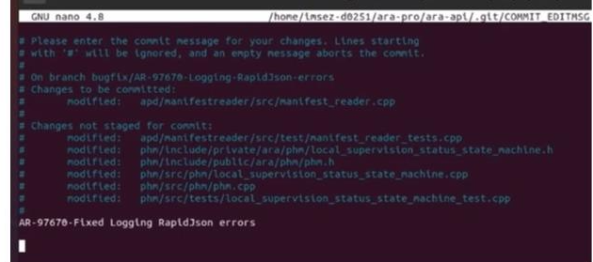

Type the message and then press Ctrl+S and Ctrl+X ->which will prompt you to the previous terminal

10. Push the branch to GitLab

viii. git push origin <branch name>
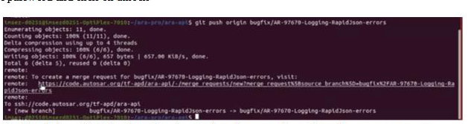

Type the password and click on unlock You will be prompted with a link to GitLab, where the changes have been made, so from there you can create a new merge request.
Right click on that link, copy the link and paste it in the browser → prompted to gitlab platform.

11. Make the changes as follows to create new merge request
• In the description box -> write Issue: Particular Ticket number
• In title box → Click on start the title with Draft → Then in the title name remove the ticket number and correct title with description

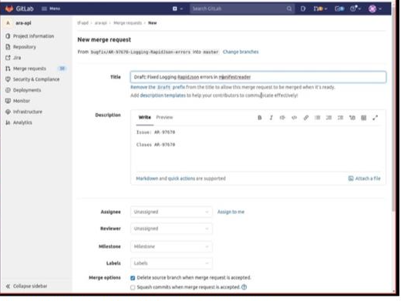

Click on assign to me and then click on create merge request.
12. Merge request will be in draft (in overview) as we need to check for CI/CD
As shown in below figure type “Jenkins rebuild” and click on comment.
After few seconds TestPipeline starts and you track the build process by clicking on that.


